Assignment 3
- Problem Statement:
- Must design 4 methods/classes that would return TRUE if a given string, is palindrome. The design of all methods definition is given.
- Design a UTILITY method taking argument string, converting to binary string.
- Develop a TEST method to test all methods with scale.
- Determine Big O, graph it.

- Analysis and Design Notes:
- From top-down design create interfaces for all methods.
- Implement structural similarities to Method classes.
- Design method classes to given description.
- Create working utility method for conversion from decimal to binary.
- Create test method.

- Code:
Method 3 is using Stack Array, Stack Queue Classes which will not be mentioned but will be added to code submission.
import java.util.Scanner;
public class Main {
public static void main(String[] args) {
MethodsClass methodOne = new MethodOne();
MethodsClass methodTwo = new MethodTwo();
MethodsClass methodThree = new MethodThree();
MethodsClass methodFour = new MethodFour();
Scanner sc = new Scanner(System.in);
System.out.println("Enter number of iterations For test");
while (!sc.hasNextInt()){
System.out.println("is not int");
sc = new Scanner(System.in);
}
int testTimes = sc.nextInt();
System.out.println("\nMethod One: ");test(methodOne, testTimes);
System.out.println("\nMethod Two: ");test(methodTwo, testTimes);
System.out.println("\nMethod Three: ");test(methodThree, testTimes);
System.out.println("\nMethod Four: ");test(methodFour, testTimes);
}
public static String utility(String input){
int decimal = Integer.parseInt(input);
StringBuilder binary = new StringBuilder();
// Handle the case of 0 separately
if (decimal == 0) {
return "0";
}
// Convert the decimal number to binary using repeated division by 2
while (decimal > 0) {
int remainder = decimal % 2;
binary.insert(0, remainder); // insert the remainder at the beginning of the StringBuilder
decimal /= 2;
}
return binary.toString();
}
public static void test(MethodsClass method, int testTimes){
int count = 0;
long start = System.currentTimeMillis();
for(int i = 0; i< testTimes; i++){
String j = Integer.toString(i);
if (method.Method(j)){
count++;
}
}
long end = System.currentTimeMillis();
System.out.println("Decimal Numbers:");
System.out.println("\tPalindrome Count: "+ count);
System.out.println("\tTime in milliseconds Count: "+ (end-start)+" ms");
System.out.println("\tOperation Count: "+ method.get_oCount() );
System.out.println("\tO(n)): "+ method.getNCount() );
count = 0;
start = System.currentTimeMillis();
for(int i = 0; i<= 1000000; i++ ){
String j = Integer.toString(i);
if (method.Method(utility(j))){
count++;
}
}
end = System.currentTimeMillis();
System.out.println("Binary Numbers:");
System.out.println("\tPalindrome Count: "+ count);
System.out.println("\tTime in milliseconds Count: "+ (end-start)+" ms");
System.out.println("\tOperation Count: "+ method.get_oCount());
System.out.println("\tO(n) Count: "+ method.getNCount() );
}
}

public class MethodOne implements MethodsClass {
protected int oCount = 0;
protected int nCount = 0;
public MethodOne() {
}
@Override
public boolean Method(String input){
String reverseString = "";
oCount += 1;
for(int i = input.length()-1; i > -1; i--){
reverseString += input.charAt(i);
oCount+=4;
nCount ++;
}
oCount++;
return reverseString.equals(input);
}
public int get_oCount(){
return this.oCount;
}
public int getNCount(){
return nCount;
}
}
public class MethodTwo implements MethodsClass {
protected int oCount = 0;
protected int nCount = 0;
public MethodTwo(){
}
@Override
public boolean Method(String input) {
for (int i = 0; i < input.length() / 2; i++) { // 3 operations
if (input.charAt(i) != input.charAt(input.length() - 1 - i)) { // 2 operations
oCount ++;
return false;
}
oCount += 5;
nCount ++;
}
return true;
}
@Override
public int get_oCount() {
return this.oCount;
}
@Override
public int getNCount() {
return nCount;
}
}

public class MethodThree implements MethodsClass {
protected int oCount = 0;
protected int nCount = 0;
public MethodThree() {
}
@Override
public boolean Method(String input) {
ArrayStack arrayStack = new ArrayStack();
ArrayQueue arrayQueue = new ArrayQueue();
oCount +=2;
for(int i = 0; i < input.length(); i++){
arrayStack.push(input.charAt(i));
arrayQueue.enqueue(input.charAt(i));
oCount += 4;
nCount ++;
}
while(!arrayStack.isEmpty() && !arrayQueue.isEmpty()){
if(arrayStack.pop() != arrayQueue.dequeue()){
oCount++;
return false;
}
nCount ++;
oCount += 3;
}
return true;
}
@Override
public int get_oCount() {
return this.oCount;
}
@Override
public int getNCount() {
return nCount;
}
}

public class MethodFour implements MethodsClass{
protected static int oCount = 0;
protected int nCount = 0;
public MethodFour(){}
@Override
public boolean Method(String input) {
String reversedStr = reverse(input);
return input.equals(reversedStr);
}
public static String reverse(String input){
if (input.isEmpty() || input.length() == 1) {
return input;
}
StringBuilder reversedSubstring = new StringBuilder(reverse(input.substring(1)));
reversedSubstring.append(input.charAt(0));
return reversedSubstring.toString();
// O(n)
}
@Override
public int get_oCount() {
return this.oCount;
}
@Override
public int getNCount() {
return nCount;
}
}

- Testing:
Test_1: Only integers are accepted | 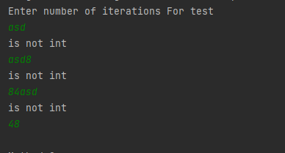
Test_2: Programme runs with shown outputs. | 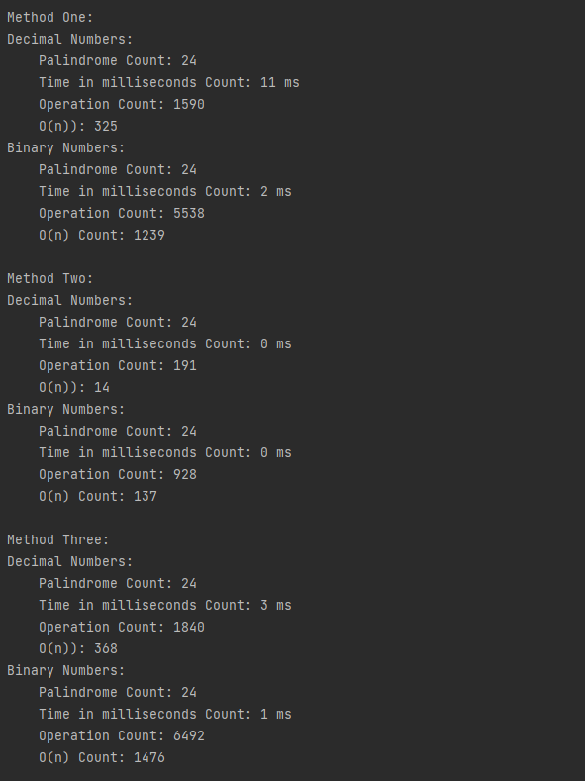
 | 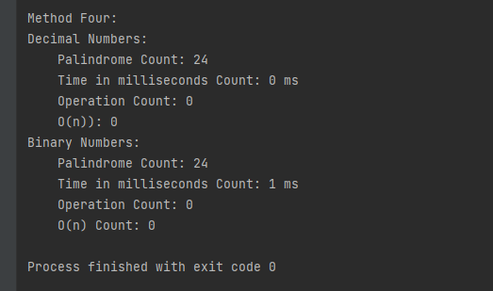
Testing Default Option of input (0). | 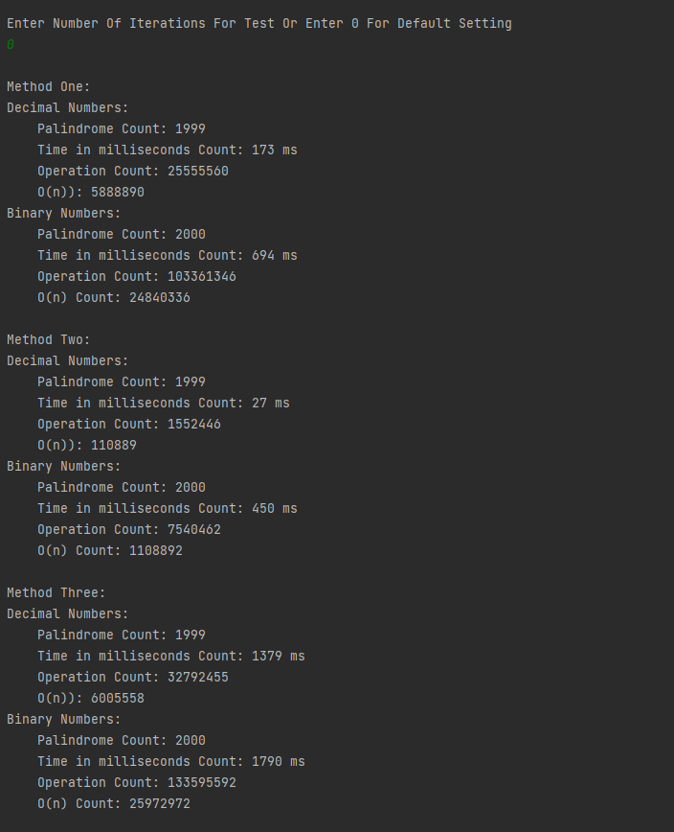

Note: I could not find a way to add recursive function calls.

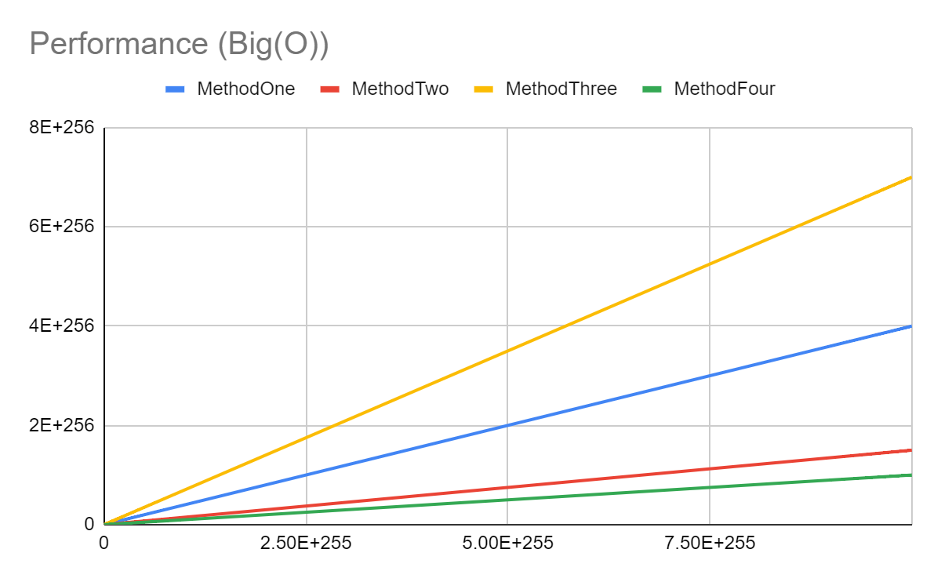
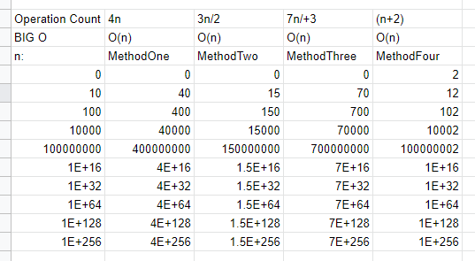

- Graph interpretation:
By calculations carried out, Method Two-time complexity is (4n), Method Two-time complexity is (3n/2), Method Three-time complexity is (7n+3), Method Four time complexity is (n+2).

BIG O: Method One Big O (n), Method Two Big O (n), Method Three Big O (n), Method Four Big O (n).

According to the analysis Method Four has the smallest Big O method applied testing if a string is a palindrome. Following by Method Two, Method One, Method Three in descending performance order.

